E-Commerce Order Management Database System
1. Project Summary
This project is a complete database system for an online shopping platform. It manages customers, products and categories, suppliers, inventory, orders, payments, shipments and reviews. Over the semester the same database was built up step by step: designed and normalized, implemented in SQL, queried for business reports, and automated with PL/SQL procedures, functions, cursors and triggers. In Week 16 all modules were integrated into one installable system and tested with an automated suite of 38 checks.

2. Modules Delivered
Weeks | Module | Deliverable
1 to 3 | Requirement analysis, ER modelling | Requirement report, ER diagram, relational schema (Section 4 and 5 below)
4 to 6 | Normalization | Functional dependencies, 1NF to BCNF design (Section 6)
7 to 8 | NoSQL study | Product catalog as JSON, SQL vs NoSQL comparison (Section 7)
9 to 11 | Database creation and sample data | Tables, constraints, 10 categories, 10 suppliers, 50 customers, 100 products, 100 orders (Week11_Populate_Database.sql)
12 | Basic SQL | 27 queries: SELECT, WHERE, ORDER BY, GROUP BY, HAVING, aggregates
13 | Advanced SQL and reports | 27 queries: joins, set operations, nested queries, business reports
14 | PL/SQL procedures and functions | 7 functions, 9 procedures for order processing, inventory and sales
15 | Cursors, triggers, exceptions | 5 triggers, 3 cursor procedures, 2 exception-handling procedures, audit and error log
16 | Integration and testing | Combined install script, 38-check test suite, reports, this document

3. Business Requirements
- Customer registration and profile management
- Product and category management, with supplier details
- Inventory tracking that stays correct when orders are placed or cancelled
- Order placement and order history
- Payment processing with validation
- Shipment tracking
- Product reviews and ratings
- Sales reporting and business analytics
- Data integrity enforced by the database itself, not only by application code

4. Entity Relationship Diagram
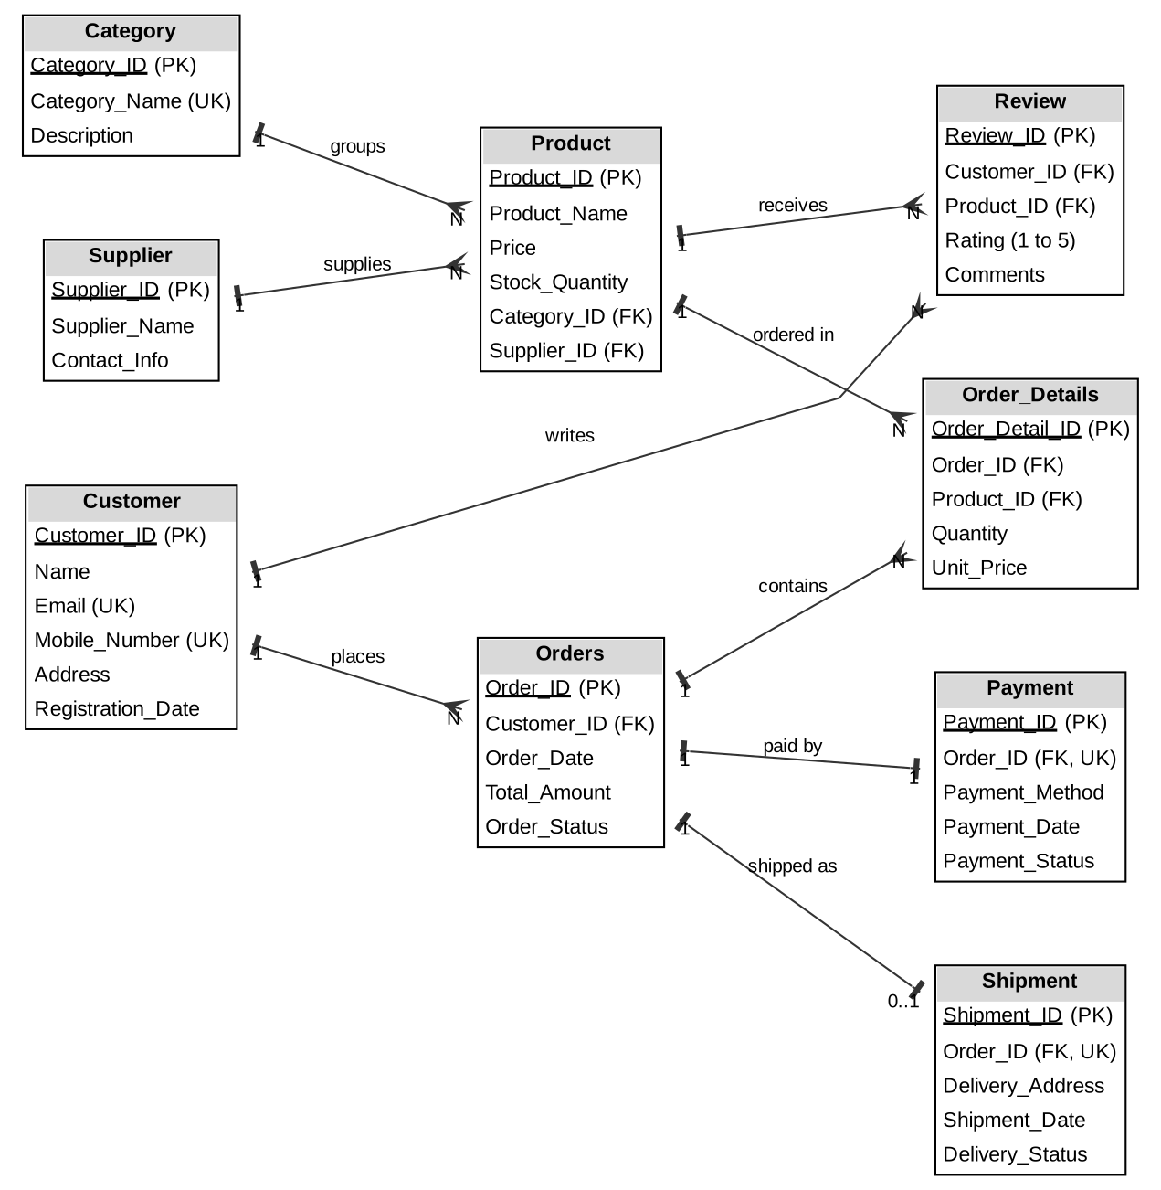
Relationship | Type | Explanation
Customer - Orders | 1 : N | A customer places many orders
Orders - Order_Details | 1 : N | An order contains one or more items
Product - Order_Details | 1 : N | Order_Details resolves the many-to-many link between Orders and Product
Category - Product | 1 : N | A category groups many products
Supplier - Product | 1 : N | A supplier supplies many products
Orders - Payment | 1 : 1 | Each order has exactly one payment record
Orders - Shipment | 1 : 0..1 | An order has a shipment only after it is shipped
Customer - Review - Product | M : N | Review links customers and products; one review per customer per product

5. Relational Schema
Table | Columns (PK underlined in design; FK noted) | Key constraints
Category | Category_ID, Category_Name, Description | PK; Category_Name unique
Supplier | Supplier_ID, Supplier_Name, Contact_Info | PK
Customer | Customer_ID, Name, Email, Mobile_Number, Address, Registration_Date | PK; Email and Mobile_Number unique
Product | Product_ID, Product_Name, Price, Stock_Quantity, Category_ID, Supplier_ID | PK; FK to Category and Supplier; Price > 0; Stock >= 0
Orders | Order_ID, Customer_ID, Order_Date, Total_Amount, Order_Status | PK; FK to Customer; status list check
Order_Details | Order_Detail_ID, Order_ID, Product_ID, Quantity, Unit_Price | PK; FK to Orders and Product; unique (Order_ID, Product_ID); Quantity > 0
Payment | Payment_ID, Order_ID, Payment_Method, Payment_Date, Payment_Status | PK; FK to Orders, unique; method and status list checks
Shipment | Shipment_ID, Order_ID, Delivery_Address, Shipment_Date, Delivery_Status | PK; FK to Orders, unique; status list check
Review | Review_ID, Customer_ID, Product_ID, Rating, Comments | PK; FK to Customer and Product; unique pair; Rating 1 to 5
Order_Audit | Audit_ID, Order_ID, Action_Type, Old/New Status, Old/New Total, Changed_By, Changed_On | PK; written by trigger
Error_Log | Error_ID, Procedure_Name, Error_Code, Error_Message, Logged_By, Logged_On | PK; written by sp_log_error

6. Normalization Decisions
- 1NF: every column holds a single value; order items are separate rows in Order_Details instead of a repeating group inside Orders.
- 2NF: product details (name, price, category) depend only on Product_ID, and are not repeated in Order_Details.
- 3NF: category and supplier details are stored once and referenced by key, so there are no transitive dependencies such as Product_ID to Category_ID to Category_Name inside one table.
- BCNF: every determinant in every table is a candidate key (for example Email and Mobile_Number in Customer, Order_ID in Payment).
- Supplier_ID was added to Product so each product points to its supplier.
- Order_Details.Unit_Price is deliberately a copy of the price at purchase time. It is history, not redundancy, because Product.Price can change later.
- Orders.Total_Amount is a derived value kept for fast reporting. It is maintained by the procedures and checked by test B1 and F1, which compare it with the sum of the items.

7. NoSQL Product Catalog (Weeks 7 and 8)
A document database suits a product catalog because products have different attributes. This illustrative document stores a product with its category, supplier and reviews together:
{
"productId": 3,
"name": "Wireless Earbuds",
"category": "Electronics",
"price": 2499,
"stock": 55,
"attributes": { "connectivity": "Bluetooth" },
"reviews": [ { "customerId": 51, "rating": 5, "comment": "Great sound quality" } ]
}

Feature | SQL (this project) | NoSQL (document store)
Schema | Fixed tables and columns | Flexible documents
Scalability | Vertical | Horizontal
Consistency | Strong (ACID transactions) | Often eventual
Best use here | Orders, payments, inventory | Large product catalog and reviews
Orders, payments and stock must stay exactly correct, so they remain in the relational database.

8. Implementation Inventory
Object type | Count | Names
Tables | 11 | 9 business tables plus Order_Audit and Error_Log
Sequences | 6 | Order, order detail, payment, shipment, audit and error IDs
Functions | 7 | fn_get_stock, fn_check_availability, fn_order_total, fn_customer_purchase_amount, fn_total_sales, fn_product_revenue, fn_price_with_gst
Procedures | 15 | Order processing (create, add item, confirm payment, ship, cancel, place order, process payment); inventory (update price, restock, low-stock report, adjust category prices); reports (sales summary, sales report, customer report); error logging
Triggers | 5 | Stock deduction, stock return on cancellation, order status rules, payment validation, order audit

9. Installation Guide
- Connect to an empty Oracle schema (SQL Developer or SQL*Plus).
- Run Week16_Install_All.sql once. It creates every table, loads the sample data and compiles all sequences, functions, procedures and triggers.
- Run Week16_System_Test.sql in order: Part 1 (installation check), Part 2 (reports), Part 3 (automated tests), Part 4 (final review).
- To start again, run Week16_Uninstall.sql, then Week16_Install_All.sql.

10. System Testing
The test suite in Part 3 of Week16_System_Test.sql runs 38 checks and prints PASS or FAIL for each. It covers installation, data integrity, the functions, a complete order journey for a new customer (register, order, pay, ship, deliver, review, cancel, failed order), the rules enforced by triggers, and a final consistency check. The last line shows the total, for example: RESULT: 38 of 38 tests passed.
Expected results: the values in the test suite were verified by running the same logic in a test database before submission, so all 38 checks are expected to pass on a clean install. Take your own screenshot of the PASS list from Oracle.
Test | Check | Expected
A1 | At least 10 categories | PASS
A2 | At least 50 customers | PASS
A3 | At least 100 products | PASS
A4 | At least 100 orders | PASS
A5 | No invalid objects | PASS
A6 | All 5 triggers are enabled | PASS
A7 | 7 functions and 15 procedures are installed | PASS
B1 | Every order total equals the sum of its items | PASS
B2 | Every order has a payment record | PASS
B3 | No product has negative stock | PASS
B4 | Shipments exist only for shipped or delivered orders | PASS
B5 | Every review is from a customer who received the product | PASS
C1 | fn_get_stock(3) returns the stock of product 3 (55) | PASS
C2 | fn_order_total(1) = 2145 | PASS
C3 | fn_customer_purchase_amount(22) = 103274 | PASS
C4 | fn_total_sales for Jan to Mar 2026 = 234489 | PASS
C5 | fn_price_with_gst(1999) = 2358.82 | PASS
C6 | fn_check_availability(3, 9999) = N | PASS
D1 | New customer registered | PASS
D2 | Order total = 2 x 2499 + 1 x 1299 = 6297 | PASS
D3 | Stock of products 3 and 4 reduced by the trigger | PASS
D4 | Payment accepted: order Processing, payment Success | PASS
D5 | Order shipped: order Shipped, shipment Dispatched | PASS
D6 | Order delivered | PASS
D7 | Customer review saved | PASS
D8 | Second order placed; stock of product 5 reduced | PASS
D9 | Cancelled: order Cancelled, payment Failed, stock restored | PASS
D10 | Out-of-stock order rejected; nothing saved | PASS
D11 | Customer purchase total excludes the cancelled order (6297) | PASS
E1 | Payment for a cancelled order is rejected (-20021) | PASS
E2 | Cancelling a delivered order is rejected (-20026) | PASS
E3 | Re-opening a cancelled order is rejected (-20025) | PASS
E4 | Invalid payment method rejected; stock unchanged | PASS
F1 | Order totals still match their items | PASS
F2 | Row counts: 2 orders, 2 payments, 1 shipment, 3 items added | PASS
F3 | Stock reconciles: product 3 -2, product 4 -1, product 5 unchanged | PASS
F4 | Audit trail: 6 rows for the main order, 3 for the cancelled order | PASS
F5 | Error log holds the 2 failed order attempts | PASS

11. Business Reports
These reports come from Part 2 of the test script and describe the sample data. Cancelled orders are excluded from revenue.
R1. Business summary
Total orders | Total revenue | Average order value | Active customers
94 | 13,27,324 | 14,120.47 | 41

R2. Orders by status
Status | Orders | Total amount
Delivered | 87 | 11,86,212
Cancelled | 6 | 1,27,058
Shipped | 5 | 1,05,274
Processing | 2 | 35,838

R3. Top 5 products by revenue
Product | Units sold | Revenue
Laptop 15.6 inch i5 | 4 | 2,11,996
Smartphone 256GB | 6 | 1,49,994
Portable Projector | 15 | 1,34,985
Noise Cancelling Headphones | 10 | 79,990
Digital Camera | 3 | 74,997

R4. Category-wise revenue
Category | Revenue | Share
Electronics | 4,62,822 | 34.87%
Computers & Laptops | 3,29,459 | 24.82%
Mobiles & Accessories | 2,27,261 | 17.12%
Women's Fashion | 95,035 | 7.16%
Home & Kitchen | 58,552 | 4.41%
Men's Fashion | 39,564 | 2.98%
Toys & Games | 32,809 | 2.47%
Books | 29,760 | 2.24%
Sports & Fitness | 28,815 | 2.17%
Beauty & Personal Care | 23,247 | 1.75%

R5. Top 5 customers
ID | Name | Orders | Total spent
45 | Revathi Selvam | 4 | 1,26,180
1 | Mohan Chandran | 2 | 1,10,639
22 | Anitha Sundaram | 5 | 1,03,274
33 | Nandhini Sundaram | 3 | 84,230
46 | Nandhini Mani | 3 | 83,639

R6. Payment methods
Method | Payments | Successful
UPI | 40 | 38
Credit Card | 22 | 20
Cash on Delivery | 16 | 15
Debit Card | 13 | 13
Net Banking | 9 | 8

R7 to R9. Monthly sales, customer report and low-stock report
These are printed by sp_sales_report(2026), sp_customer_report(100000) and sp_low_stock_report(40). Their expected output is listed in the Week 14 and Week 15 reports: ten months from 2026-01 to 2026-10 with 94 orders and revenue 1327324; three Gold customers (45, 1 and 22); and five products below 40 units of stock.

12. Demonstration Script (about 10 minutes)
# | Topic | What to show | Time
1 | Requirement analysis | Section 3: the business scenario and what the system must do | 1 min
2 | ER diagram | Section 4: entities, keys and cardinalities; explain Order_Details and Review | 1.5 min
3 | Normalized design | Section 6: 1NF to BCNF decisions, Unit_Price and Total_Amount choices | 1.5 min
4 | Implementation | Run Week16_Install_All.sql, then query 1.1 (row counts) and 1.2 (object counts) | 1 min
5 | SQL queries | Pick three from Week 12 and 13: a GROUP BY with HAVING, a join across four tables, a nested query | 2 min
6 | PL/SQL features | Run the Part 3 test suite and show 38 of 38 PASS; explain the stock trigger, a rejected action (E1 to E3) and the audit trail (query 4.2) | 2 min
7 | Reports and analytics | Run R1 to R6 and the cursor reports; explain what each tells the business | 1 min
8 | Close | Design decisions and future work (Section 13) | 0.5 min

13. Design Decisions, Limitations and Future Work
- Business rules live in the database (constraints, triggers, procedures), so they apply no matter which application connects.
- Each procedure commits its own transaction, which keeps every business operation all-or-nothing but means procedures cannot be combined into one larger transaction.
- The Week 11 sample orders were loaded before the triggers existed, so their stock was never deducted. Cancel only orders created through the procedures.
- The sample data is generated for learning and contains no real people.
- Future work: customer login and roles, discounts and coupons, multi-item order procedure, returns and refunds, and indexes and partitioning for very large data.

